Movie Landing Page Website Design

Name : kistipati subbareddy

Mail Id : kristipatisubbareddy211@mail.com

Phn No : 7993484940

Roll N0 : 20HU1A0424

College Name : Chebrolu engineering college

**Source Code:**

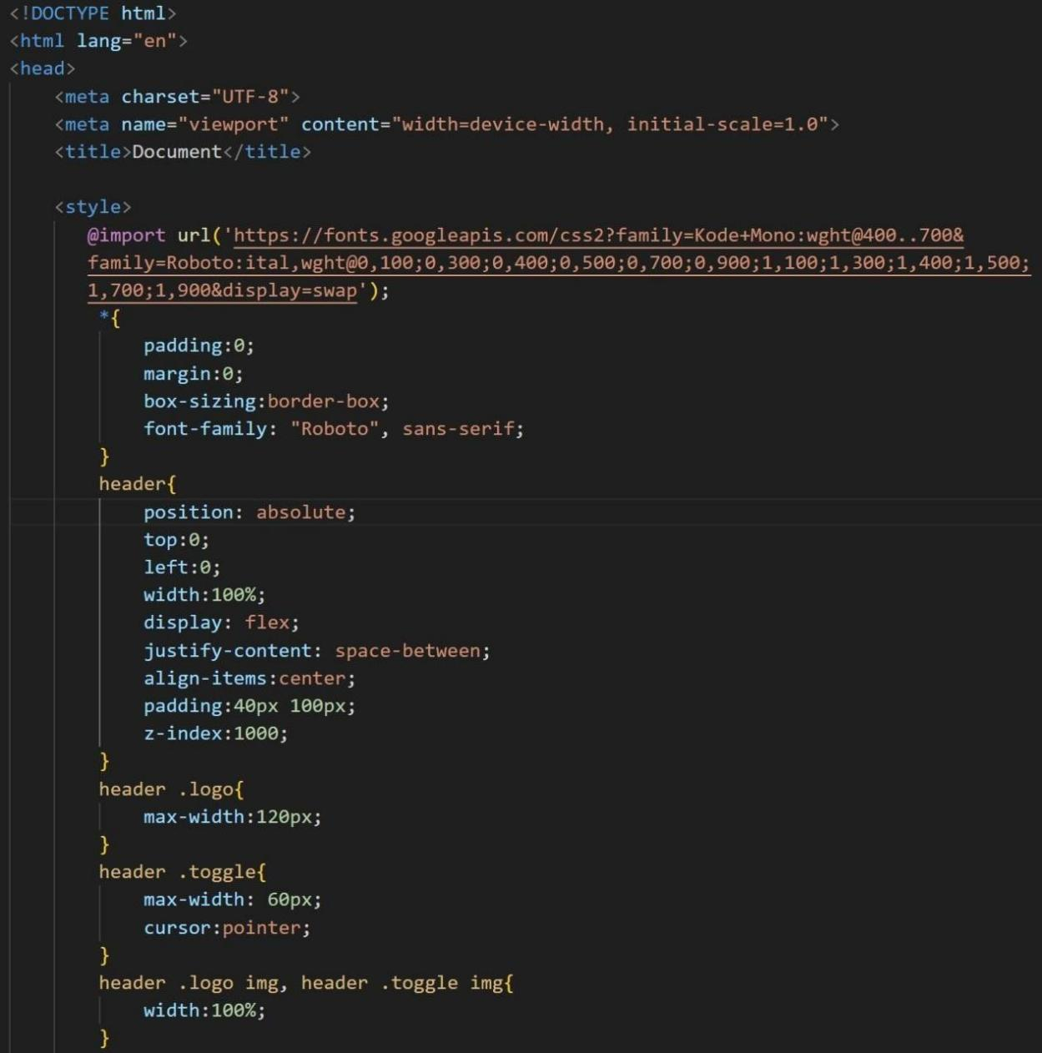

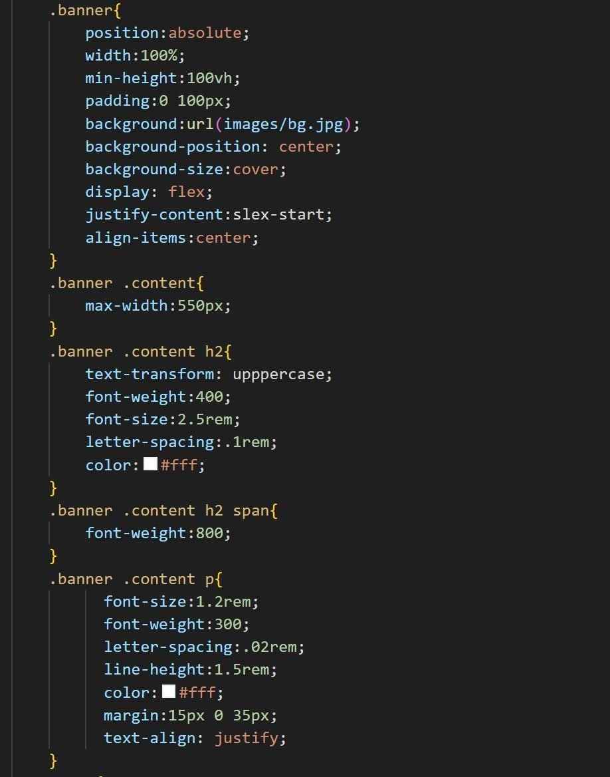

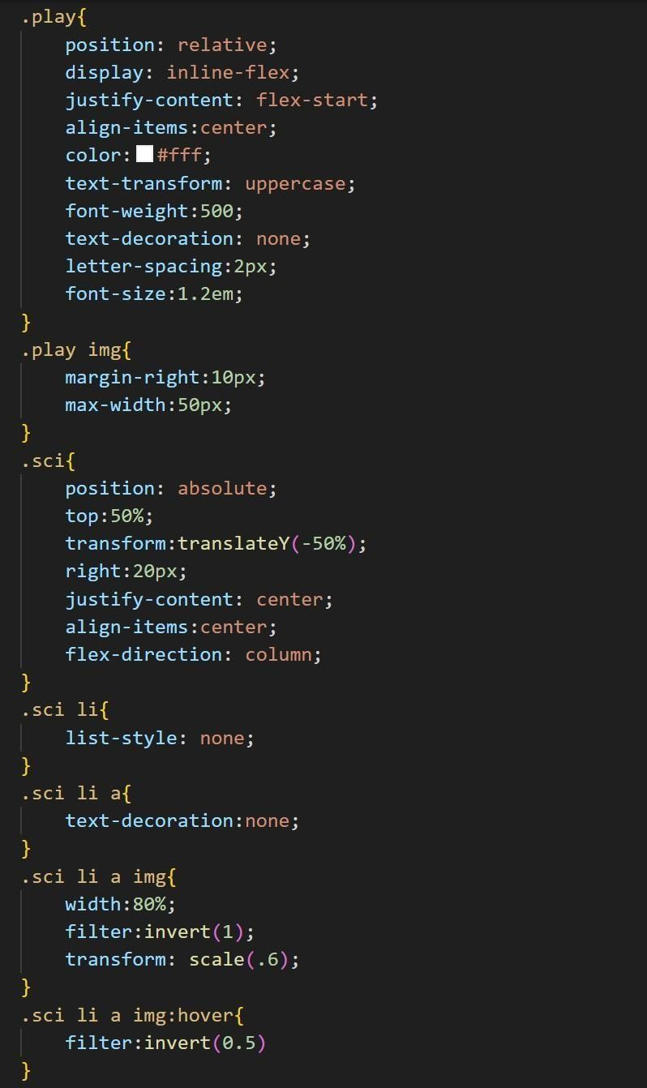

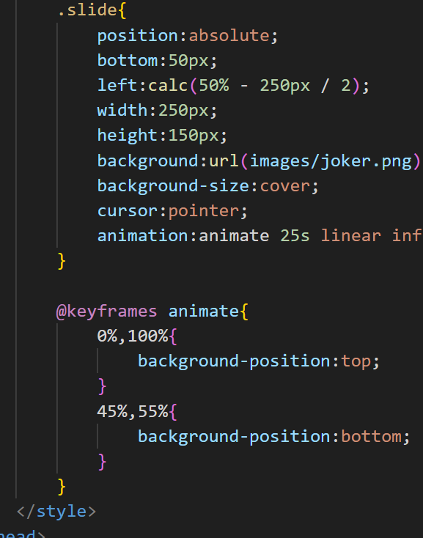

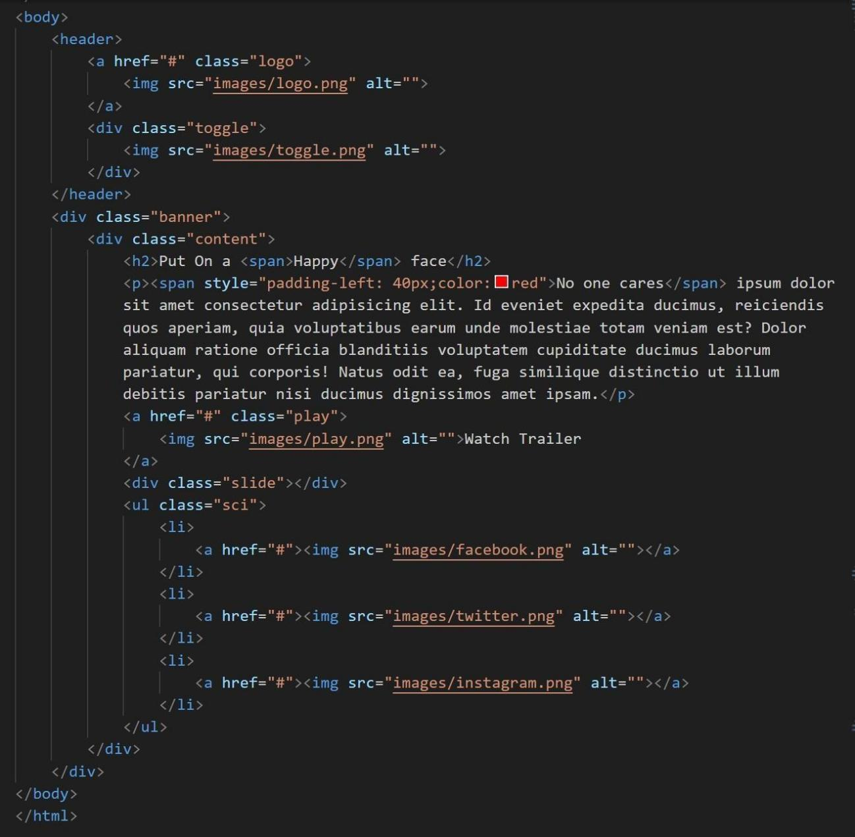



**Output :**